1. INTRODUCTION

Efficient utilization of manpower has always been a key concern in organizations. This is one of the most important means to achieve gains in productivity. Because of its importance, considerable effort has been devoted to tackling various personnel-scheduling problems in the literature.

Personnel scheduling is concerned with the determination of appropriate workforce requirements, workforce allocation and workforce duty assignments for an organization in order to meet internal and external requirements. This involves allocating people (personnel) to timeslots and possibly locations. Not surprisingly, personnel scheduling has been the subject of much investigation in the literature over the past 30 years with at least one survey article for every decade.

Because the problem environment differs from one case to another, personnel scheduling problem has been applied to a variety of applications in the literature. Here we consider the problem of scheduling the tour of a marketing executive of a large electronics manufacturing company in India. This problem differs significantly compared with many other personnel scheduling problems addressed so far in the literature.

This type of personnel scheduling problem can be observed in many other situations such as periodical visits of inspection officers, tour of politicians during election campaigns, schedule of mobile courts, schedule of mobile stalls in various areas, etc. A (0-1) goal programming and heuristic approach is proposed for modeling the tour scheduling of marketing executive.

2. LITERATURE SURVEY

Personnel or staff or tour scheduling problems have been studied for many years as they contribute to the improvement of the overall performance of a system in terms of quality of service to the customer and cost to the organization. These problems involve the allocation of staff to timeslots and possibly locations.

These scheduling problems cover many areas, such as the tour scheduling problem in a post office setting (Ritzman et al. 1976; Bard et al. 2003), scheduling personnel in a newspaper publishing environment (Gopalakrishnan et al. 1993), the transportation staff scheduling (Wren and Wren, 1995), scheduling of cashiers in a supermarket (Melachrinoudis and Olafsson, 1995), nurse rostering problem (Dowsland, 1998; Burke et al, 2001;), audit staff scheduling (Dodin et al. 1998), educational institute staff scheduling (Schaerf, 1999), airline crew-scheduling (Emden-Weinert and Proksch, 1999), scheduling a sales summit (Cowling et al., 2000), scheduling of laboratory personnel (Boyd and Savory, 2001) and scheduling pharmaceutical sales representatives (Hertel and Gautam, 2004).

However, the scheduling of the visits of a ME (a tour scheduling) problem taken up in this study seems to be significantly different from the various personnel scheduling problems addressed in the literature.
Given the wide variety of tour scheduling problems, different approaches including mathematical programming and computational approaches have been employed in solving them.

The various employee tour-scheduling approaches in the literature have many different objectives and assumptions, and therefore a wide variety of mathematical formulation approaches such as set covering, goal programming, and implicit modeling. Since the goal programming approach to Scheduling of Marketing Executive takes considerable time to produce good result, we are proposing a series of heuristic algorithms, 6 to be precise that help produce speedy solutions to the problems. The various solution methodologies are discussed in detail in chapter 4.

Efficient utilization of manpower has always been a key concern in organizations. This is one of the most important means to achieve gains in productivity. Because of its importance, considerable effort has been devoted to tackling various personnel-scheduling problems in the literature. Personnel scheduling is concerned with the determination of appropriate workforce requirements, workforce allocation and workforce duty assignments for an organization in order
to meet internal and external requirements. This involves allocating people (personnel) to timeslots and possibly locations. Not surprisingly, personnel scheduling has been the subject of much investigation in the literature over the past 30 years with at least one survey article for every decade. Because the problem environment differs from one case to another, personnel scheduling problem has been applied to a variety of applications in the literature.

Here, we consider the problem of scheduling the tour of a marketing executive of a large electronics manufacturing company in

India. Based on our observations of this problem in the company and the various personnel scheduling problems addressed in the literature, we felt that this problem differs significantly compared with many other personnel scheduling problems addressed so far in the literature. This type of personnel scheduling problem can be observed in many other situations such as periodical visits of inspection officers, tour of politicians during election campaigns, schedule of mobile courts, schedule of mobile stalls in various areas, etc.

3. PROBLEM DEFINITION
3.1 Problem Definition

The problem of tour scheduling of a marketing executive (ME) of a company may be stated as follows.

We are given a set of regions R = {r1, r2, ….rm} having a number of customers in a city. Each region ri is covered by one marketing executive. The ME assigned to each region has to visit periodically all the customers clustered in the region for continuously increasing the business interactions between the customers and the company.

The number of effective working days for ME in a given planning period is accounted after excluding the holidays of the company, customer holidays and the days in which the ME has to make full-day visits to head-office. For each ME, the head-office visit-days varies, except the last visit, in the planning period. All the marketing executives assemble at the head-office during their last head-office visit towards the end of planning period for a common discussion on the business strategy.

Accordingly, for every planning period and for every ME, the set of days not scheduled for customer visits is M = {holidays for the company, holidays for individual customers, days for full-day visits to head-office}.

Each region has a set of customers C = {c1,c2,….cn} and each customer has different level of business transactions with the company. Accordingly, based on the business transactions with the company, the customers are classified as A-type, B-type and C-type, which is similar to ABC-inventory classification. Thus class A customers have a highest level of business transaction in the company, followed by Class B and C customers. As per the policy of the company, the number of visits made by the ME to a customer is directly proportional to the customer’s level of business transaction. That is, the ME should visit class A customer more number of times in a given planning period compared to the number of visits to class B and C customers. Thus, if ME has to visit each A-type customers NA times, each B-type customers NB times and each C-type customers NC times in the planning period then NA > NB > NC.

As per the policy on each customer’s number-of-visits, the company puts a condition that the ME has to maintain an appropriate time-interval between the consecutive visits of any customer in the planning period. The time-interval between the consecutive visits is a function of effective number of working days available for the ME in the planning period and number of required visits to a customer. In addition to the time-interval condition, the company specifies upper and lower bounds on the number of customer to be visited per day. As the company divides logistically their customers in the city into a multiple regions and one ME is assigned to each region for the continuous and efficient development of their business with customers, in subsequent chapters we address the scheduling of tour of a single ME.

3.2 Assumptions

- There are no restrictions/limitations in moving from one customer to another.

- The Time and Cost of traveling from one customer to another is not explicitly incorporated.

- The working hours and pattern (if any) remain the same for both customer and ME of the company.

- The emergency requirement of any customer is not addressed.

- The policy decisions of the management of the customers such as type of customer, number of visits of a customer, etc., do not change during the planning period.

- Natural calamities are not accounted for in the solution development.

- The model specifies the customers to be visited by the ME on any working day, but does not specify the sequencing of the customers.

- The Total number of visits required by all the customers in the planning period should be less than or equal to the total number of trips expected to be made by the ME in the planning period.

- It is assumed that, if a Head Office Visit falls on any General Holiday, then that day is taken as General Holiday.

4. PROJECT REQUIREMENTS DEFINITION

Requirements definition basically gives the services the system provides and the constraints under which the system must operate.

The main aim of our project is to schedule the visits of a Marketing executive to the customers of a large electronics company. This scheduling is called personal scheduling. Several personal scheduling problems are available in literature. These are scheduling problem in a post office setting, scheduling personnel in a newspaper publishing environment, the transportation staff scheduling, scheduling of cashiers in a supermarket, nurse rostering problem, audit staff scheduling, educational institute staff scheduling, airline crew-scheduling etc...

The ME visit must be scheduled considering the various general holidays, head office visits, customer closure days during which either the ME or the customer will be unavailable. Also there must be a definite interval between visits so that the visits are evenly distributed throughout the scheduling period.

Then there are the constraints that must be satisfied. As per the policy of the company, the number of visits made by the ME to a customer is directly proportional to the customer’s level of business transaction. That is, the ME should visit class ‘A’ customer more number of times in a given planning period compared to the number of

visits to class B and C; Class B customers must be visited more number of times than Class C and so on.

Also there is a limit on the number of customers to be visited in a day and the number of times a customer can be visited in a month. All these constraints must be met with while scheduling the visit of ME.

5. SYSTEM REQUIREMENTS SPECIFICATION

The various hardware and software requirements for our project are:
Hardware Requirements

- CPU Speed 800 MHz (minimum).

- 256 MB RAM.

- Monitor, Key Board, Mouse.

Software Requirements

- Microsoft Visual Studio .NET (C#)

For scheduling the visit of ME we must be provided with basic details such as the scheduling period, type and number of customers, the number of times a customer of a particular type needs to be visited, the maximum and minimum number of visits a ME can make in a day, penalty values in case of violations, holidays (general holidays, customer closure day, head office visits), the identity of customers.

6. GANTT CHART
The project schedule started from FEB 2005 and ended in MAY 2005. The Different Phases identified are:
- Requirement Analysis.
- Requirement Specification.
- System Design.
- Detailed Design.
- Coding.
- Testing.

The Gantt chart as shown below represents the approximate schedule followed for the completion of each phase.
Requirement
Analysis

Requirement
Specification

System Design
Detailed Design

Coding
Testing

FEB MARCH APRIL MAY

Fig 6.1 Gantt chart

7. SYSTEM DESIGN

7.1 Solution Methodology - Goal Programming

The roots of Goal Programming (GP) lie in a paper by Charnes et al. (1955), which deals with executive compensation methods. A more explicit definition is given by Charnes and Cooper (1961), in which the term Goal Programming is first used. GP is a powerful technique since it can handle multiple objectives. Unlike Linear Programming, the GP model does not optimize (maximize/minimize) the objectives directly. Instead, it attempts to minimize the deviations between the desired goals and the realized results. Also, these goals must be prioritized in a hierarchy of importance. The over and under achievements of goals is measured in GP using the so called deviation variables. A commonly used generalized model for goal programming is as follows (Kwak et al. 1991):

k
Min ∑ Pi(w_{i} ⁺ d _{i} ⁺ + w_{i}– d_{i}– )
i

s.t C¹X + d₁⁺ - d₁– = t₁
.
.

C ^{k} X + dk⁺ - dk– = t_{k}

X ∈ S

X, d_{k}⁺, d_{k}– ≥ 0

In which S is the feasible region; P_{i} is the preemptive factor/priority level assigned to each relevant goal in rank order (i.e. P₁ > P₂ > P_{k}), CX is the i^{th} goal criterion function, and t_{i} are the target values of the k goal criteria. The variables d_{i}⁺ and d_{i}⁻ are the deviational variables, which measure achievements below and above goal. The w_{i}⁺ and w_{i}⁻ are relative importance weights attached to the underachievement and overachievement deviational variables.

The constraints involved in a GP model are broadly grouped into (i) hard constraints and (ii) soft constraints. Hard constraints are constraints that cannot be violated. For instance, the constraint that the ME can only be present at one place at one time is a hard constraint. Soft constraints are constraint that can be violated and the solution may still be acceptable. For instance, the expected time interval between two consecutive visits of a customer by the ME can be violated marginally. But we must be able to know how far we can bend a soft constraint. A common way to manage soft constraints is to assign goals to each of them, to associate deviational variables representing over and under achievements of the respective goals, and to minimize the sum of these deviational variables in the objective function.

The advantage of GP is that multiple objectives can be incorporated into a model that can be solved using conventional (single objective) optimization software. A major disadvantage of GP is that it requires about the decision maker’s preference among objective

a priori in the form of priority levels, importance weights, and goal target values.

One of the main problems of applying goal programming is that the optimal solution to marketing scheduling problem will be available only in 5-6 days. Hence an alternative heuristic approach that provides quicker result is proposed.

7.2 Solution Methodology - Heuristic Approach

Pre Scheduling Activity

- Accept scheduling (planning) period.

- Accept data pertaining to holidays. These include Head Office Visit, Customer Closure Day and also General Holidays.

- Accept data regarding “Type” and number of customers in each type, number of “Visits” required to each customer, number of visits allowed in a day.

HA1: Systematic Approach.
Step 1) Perform steps 1 to 3 of prescheduling activity.

Step 2) Calculate the effective working day for Marketing Executive
(M.E.) as follows W = P – H
Where W = Working Days,
P = Scheduling Period,

H = no. of holidays (General holidays + head office visit
day + customer closure day)

Step 3) Compute the time interval for scheduling the M.E to visit a
customer.

T[i] = W/V[i]
where T[i] = Time Interval of each Customer,
W = no of effective working days,
V[i] = number of visits required to a each customer

Step 4) When scheduling for the 1st customer, assign the M.E. to visit the customer on the 1st effective working day. Time interval between subsequent visits must be according to the interval data computed in the previous step. This scheduling takes the form of a circular queue. If the M.E visit is scheduled to visit towards the end of his working period and the number of visit constraint has not been met with, the algorithm adjusts the balance by scheduling the M.E. visit in the beginning of

the effective working day period until the constraint is satisfied while maintaining the time interval between visits. The algorithm also ensures that number of visits possible in a day constraint is also met.

Step 5) For the 2nd customer, schedule the M.E. to visit the customer on the 2nd day of his effective working period. Repeat the process carried out in Step 1. Similarly schedule the M.E. to visit customers 3, 4,…… and so on.

Step 6) Finally during completion of scheduling we take care of the minimum visits in a day constraint. The ME schedule will be adjusted to ensure that this constraint is met to the best possible extent.

HA2: FDFC Approach
Here FDFC stands for First Day First Customer algorithm. The scheduling process is similar to that of Systematic scheduling algorithm but with a major difference. Here we attempt to schedule the M.E. to visit various customers on the start day of working period as long as the number of customers to be visited in a day constraint does not get violated. When this limit is exceeded, the M.E. starts to visit the pending customers on the 2nd day of the working period until the constraint is not violated and then starts to visit on the 3rd day and so on.
The scheduling process is similar to that of systematic scheduling algorithm. This can also be called as greedy algorithm. The scheduling starts from the 1st effective working day and proceeds towards the last effective working day.

HA3: LDFC Approach.
Here LDFC stands for Last Day First Customer. This is same as the FDFC algorithm explained above with a major difference. The scheduling starts from the last effective working day and proceeds towards the 1st effective working day.

Random Approaches:
Here we discuss 3 types of random scheduling algorithm

HA4: Random Approach
This algorithm is similar to systematic scheduling algorithm. One major difference is that the starting day for scheduling the M.E. is chosen randomly. The process for scheduling the M.E. is similar to that of systematic scheduling algorithm mentioned above.

HA5: Random Approach.
For each customers belonging to a particular customer type, the order in which customers are visited by M.E is chosen randomly and scheduling is carried out in a way similar to that of algorithm mentioned above.

HA6: Complete Random Approach.
Here both the customers and start day for scheduling is chosen in random and scheduling is carried out in a manner similar to that of systematic scheduling algorithm.

7.3 Numerical Example

Inputs:
General Input

Scheduling Period | 15
Total Customers | 5
Types of customers | 2
No of Type A customers | 3
No of Type B customers | 2
No of visits to Type A customers | 3
No of visits to Type B customers | 2
Maximum visits in a day | 4
Minimum visits in a day | 3

Table 7.1 Input

Holidays Input

Company Holiday | 0
Head office visit day | 1
General Holiday | 1st day of the scheduling period

Table 7.2 Holidays Input

Penalty

Penalty for type A violation | 25
Penalty for type B violation | 10
Penalty for type C violation | 01

Table 7.3 Penalty

Pre-Scheduling Matrix

5 | 2 | 9 | 0 | 0 | 0 | 0 | 4 | 2 | 9 | 0 | 0 | 0 | 0 | 4
5 | 2 | 0 | 0 | 9 | 0 | 0 | 4 | 2 | 0 | 0 | 9 | 0 | 0 | 4
5 | 2 | 0 | 0 | 9 | 0 | 0 | 4 | 2 | 0 | 0 | 9 | 0 | 0 | 4
5 | 2 | 0 | 0 | 9 | 0 | 0 | 4 | 2 | 0 | 0 | 9 | 0 | 0 | 4
5 | 2 | 0 | 0 | 9 | 0 | 0 | 4 | 2 | 0 | 0 | 9 | 0 | 0 | 4

Table 7.4 Pre-schedule matrix

The scheduling of ME based on these numerical data has been manually solved and their results verified by using our software.

Outputs

Results of scheduling ME visits according to various algorithms has been displayed in the tabular form where each row represents customers and each column represents days in the scheduling period.

Systematic Approach

5 | 2 | 9 | 1 | 1 | 0 | 0 | 4 | 2 | 9 | 1 | 0 | 0 | 0 | 4
5 | 2 | 0 | 0 | 9 | 1 | 1 | 4 | 2 | 0 | 0 | 9 | 1 | 0 | 4
5 | 2 | 0 | 0 | 9 | 0 | 1 | 4 | 2 | 1 | 0 | 9 | 0 | 1 | 4
5 | 2 | 0 | 0 | 9 | 1 | 0 | 4 | 2 | 1 | 0 | 9 | 0 | 0 | 4
5 | 2 | 0 | 0 | 9 | 0 | 1 | 4 | 2 | 0 | 1 | 9 | 0 | 0 | 4

Table 7.5 Systematic Method

FDFC Approach

5 | 2 | 9 | 1 | 1 | 0 | 0 | 4 | 2 | 9 | 1 | 0 | 0 | 0 | 4
5 | 2 | 1 | 1 | 9 | 0 | 0 | 4 | 2 | 1 | 0 | 9 | 0 | 0 | 4
5 | 2 | 1 | 1 | 9 | 0 | 0 | 4 | 2 | 1 | 0 | 9 | 0 | 0 | 4
5 | 2 | 1 | 0 | 9 | 0 | 0 | 4 | 2 | 0 | 0 | 9 | 1 | 0 | 4
5 | 2 | 1 | 0 | 9 | 0 | 0 | 4 | 2 | 0 | 0 | 9 | 1 | 0 | 4

Table 7.6 FDFC Method

LDFC Approach

5 | 2 | 9 | 0 | 0 | 0 | 1 | 4 | 2 | 9 | 0 | 0 | 1 | 1 | 4
5 | 2 | 0 | 0 | 9 | 0 | 1 | 4 | 2 | 0 | 0 | 9 | 1 | 1 | 4
5 | 2 | 0 | 0 | 9 | 0 | 1 | 4 | 2 | 0 | 0 | 9 | 1 | 1 | 4
5 | 2 | 0 | 1 | 9 | 0 | 0 | 4 | 2 | 0 | 0 | 9 | 0 | 1 | 4
5 | 2 | 1 | 0 | 9 | 0 | 0 | 4 | 2 | 0 | 0 | 9 | 1 | 0 | 4

Table 7.7 LDFC Method

Random Days Approach

5 | 2 | 9 | 1 | 0 | 0 | 0 | 4 | 2 | 9 | 1 | 1 | 0 | 0 | 4
5 | 2 | 1 | 0 | 9 | 0 | 0 | 4 | 2 | 1 | 1 | 9 | 0 | 0 | 4
5 | 2 | 0 | 0 | 9 | 1 | 1 | 4 | 2 | 0 | 0 | 9 | 1 | 0 | 4
5 | 2 | 1 | 0 | 9 | 1 | 0 | 4 | 2 | 0 | 0 | 9 | 0 | 0 | 4
5 | 2 | 0 | 1 | 9 | 0 | 1 | 4 | 2 | 0 | 0 | 9 | 0 | 0 | 4

Table 7.8 Random Days

Random Customers Approach

5 | 2 | 9 | 1 | 1 | 0 | 0 | 4 | 2 | 9 | 1 | 0 | 0 | 0 | 4
5 | 2 | 1 | 1 | 9 | 0 | 0 | 4 | 2 | 1 | 0 | 9 | 0 | 0 | 4
5 | 2 | 1 | 1 | 9 | 0 | 0 | 4 | 2 | 1 | 0 | 9 | 0 | 0 | 4
5 | 2 | 1 | 0 | 9 | 0 | 0 | 4 | 2 | 0 | 0 | 9 | 1 | 0 | 4
5 | 2 | 1 | 0 | 9 | 0 | 0 | 4 | 2 | 0 | 0 | 9 | 1 | 0 | 4

Table 7.9 Random Customers

Complete Random Approach

5 | 2 | 1 | 0 | 9 | 0 | 0 | 4 | 2 | 1 | 0 | 9 | 1 | 0 | 4
5 | 2 | 1 | 0 | 9 | 0 | 0 | 4 | 2 | 1 | 0 | 9 | 0 | 0 | 4
5 | 2 | 9 | 0 | 0 | 0 | 1 | 4 | 2 | 9 | 0 | 1 | 0 | 1 | 4
5 | 2 | 1 | 0 | 9 | 0 | 0 | 4 | 2 | 1 | 0 | 9 | 0 | 0 | 4
5 | 2 | 0 | 0 | 9 | 0 | 1 | 4 | 2 | 0 | 1 | 9 | 0 | 1 | 4

Table 7.10 Complete Random

The following representations are used in the output
0 – Not Scheduled, but feasible for Scheduling.
1 – Scheduled for ME to visit the Customer.
2 – Head Office Visit.
4 – Company Closure Day.
5 - General Holiday.
9 – Customer closure Day.

8. DETAILED DESIGN & IMPLEMENTATION

8.1 Decision Support System (DSS)
Decision Support Systems (DSS) are a major category of management support systems. They are computer based information systems that provide interactive information support to managers during the decision making process. Decision support systems use
- Analytical Models
- Specialized databases
- Decision maker’s own insights and judgments
- An interactive, computer based modeling process to support the making of semi structured and unstructured decisions by individual managers.

8.1.1 DSS versus EDP, MIS and TPS

Computers have been in use in the industry for many years now. Even after computerizing the major functional areas, the manager still feels there is something lacking.

With the introduction to Transaction Processing systems, the work of clerks and typists became comfortable. Accurate invoices, Purchase orders and similar documents are generated at remarkable speeds by TPS. With the introduction of line Transaction Processing, outputs are available then and there.

With the introduction of computerized Management Information System (MIS), the managers started getting accurate and fast information. But still the operating managers often complain about the help they get from traditional computer based MIS, especially in the process of decision-making.

The operating managers often complain that the existing MIS is provided insufficient information for decision-making. The right kind of information required for decision-making is either not available or is difficult to get. There are several comments that are made about the traditional computer based MIS. It would be worthwhile to try and classify the common frustrations about MIS some of which are: too much data, too many reports and very little information to have decisions on.

For overlooking the frustrations about MIS, managers are looking for computer system that will support them in decision- making. This is being achieved through DSS.

The objective of DSS is to support a manager in his work, especially in decision-making. DSS is also an end user computing system and overlaps the TPS as well as office support systems. DSS acquire most of their basic data from routine transaction processing. In addition some data is also required from office support systems. DSS is used in planning, modeling, analyzing alternatives and decision-making. These are especially useful for semi-structured problems where problem solving is improved by interaction between manager and computer system. The emphasis is on small simple

model that can be easily understood and used by the manger rather than complex integrated system that need information specialists to operate them. The definition and characteristics of DSS is given in the next section.

Decision Focus DSS

Information MIS
Focus

Data EDP
Focus

Transaction TPS

Focus

Fig 8.1 Connotational View of EDP/MIS/DSS

8.1.2 Definition and Characteristics of DSS

Michael S. Scott Morton first articulated the concepts involved in Decision Support System (DSS) in the early ‘70’s under the term “management decision systems”. The Decision Support System, as the name implies provides support in the decision-making activity. The DSS does not replace the job of decision-making but supports it. The decision–making activity remains in the hands of the Manager. A comprehensive and universally acceptable definition of the definitions put forth by experts in the field (Turban, 1990).

Scott-Morton (1971) defined DSS as “Interactive computer based systems which help decision-makers utilized data and models solve un-structured problems”.

According to Keen and Scott-Morton (1978) DSS represent a point of view on the role of the computer in the decision making process, and decision support implies the use of computers to:

- Assist managers in their semi structured decision task.
- Support, rather than replace, managerial judgment.
- Improve the effectiveness of decision making rather than its efficiency.

Moore and Chang (1980) argue that the “structuredness” concept, so much part of early DSS definitions (i.e., that DSS can handle semi-structured and un-structured situations), is not meaningful in general; a problem can be described as structured or un-structured only with

respect to a particular decision maker (i.e., structured decisions are structured because we choose to treat them as such). Thus they defined DSS as

- Extendable systems.
- Capable of supporting ad hoc data analysis and decision modeling.
- Oriented towards future planning and
(d) Used at regular un-planned intervals.

Mann and Watson (1984) observes that DSS is an interactive system that provided the user with easy access to decision models and data in order to support semi structured and unstructured decision making tasks.

Blanning (1986) states that an important purpose of the research being done in DSS is to develop a framework for information management that is an independent as possible of the way in which the information is stored and processed.

A DSS may be defined more specifically by its capabilities in several critical areas-capabilities, which are required to accomplish the objectives which are pursued by the development and use of a DSS (Sprague, 1993).

Further, the computerized systems for decision support are being developed today by end-users on microcomputers for dealing with fairly structured problems. The advantage here is that the user

can build systems with little or no help from information systems people. From the above definitions, it is evident that there is no universal definition of DSS.

However, most authors agree with the following characteristics of DSS (Acharya, 1989).

- A DSS assists managers in their decision making specifically in semi structured and unstructured problem situations.
- A DSS supports and enhances, rather than replace, managerial judgments.
- A DSS improves the effectiveness of the decision rather than its efficiency.
- A DSS combines the use of models and analytical techniques with conventional data access and retrieval functions.
- A DSS has features (including interactive features) which make its use by non-computer people easier.
- A DSS has enough flexibility to accommodate changes in the environment, in the approach and the needs of the users.
- A DSS supports managers at all levels who take decisions.
- A DSS is user initiated and user controlled.
- A DSS supports the personal decision making styles of individual managers.

8.1.3 Impact of DSS on Management

A DSS is designed and implemented with managers as the end users. Its impact is on decisions in which there is sufficient structure for computer tools and analytical techniques to be useful but where the manager’s judgment is essential. The real payoff from the manager’s viewpoint is in the degree to which the DSS as a supportive tool under his/her decision-making process to make it more effective. The manager sees the DSS as a supportive tool under his/her own control that does not attempt to automate the decision process, predefine objectives, or impose solutions. It accepts input from the manager, process it, and then provides the output for review. If the output is not satisfactory, then the manager can repeat the process until the solution is satisfactory, then the manager can repeat the process until the solution is satisfactory, as shown in the following figure.

Keyed user input

DSS
Terminal display for user

Fig 8.2 DSS impact on management

It must be clearly understood that no DSS can ever take the decision-making authority away from its users. Many managers, especially those who are not familiar with computer technology, have

an inherent fear of the DSS. They fail to realize that it is just a tool to be used for making better and quicker decisions.

While managers play the role of end users of a DSS, analysts and designers get involved with the actual building of the system. These two groups are technical persons who usually belong to the middle management level in the company or are outside consultants fro vendors of DSS.

The analysts are from a technical liaison between the managers and the designers. They must have some familiarity with the general problem area and must also be fairly comfortable with the information system technology components and capabilities. The designers are the

really technical people who develop new analytical models, new databases to store data for easy access and retrieval, and appropriate prompts and display formats for user-friendly interaction with DSS. In this task the designers use or even develop new hard ware and software.

The components of DSS are explained in detail in the section 8.2.1.

8.2 A prototype DSS for Scheduling of Marketing Executive

8.2.1 Components of DSS
A DSS is composed of the following three components.
Data Management Module (DMM) manages all the data required by the DSS. The data is organized in such a way that it is easy to generate reports based on the data. The model management module will use the data created and maintained by this module. A software should exist that can retrieve data and produce reports. This module is supported by report-generating module in various forms.

Model Management Module (MMM) has all the quantitative model-building software. It utilizes optimizing modeling principles, heuristic algorithms, statistical analysis, forecasting algorithms, decision analysis methods and simulation principles. Usually the MMM is the most difficult component in a DSS to design, since the selection of appropriate algorithms from the vast repertoire of mathematical models is a non-trivial job. In addition if a specific modeling algorithm does not lead to an explicit solution, then user must take recourse to simulation method.

Control Module (CM) also known as the front end is menu driven an interfaces with two other modules. The CM has to be user friendly in the sense that it can help a non-computer oriented user utilize the DSS. The prompts and messages should be written in simple English as far as practicable and avoid computer jargon. Since the control

module provides interfaces to all other modules, it should be designed and implemented first. Success of a DSS depends to a large extent on the efficiency of the control module.

MMM

DMM

CM/UIM

COMPUTER
SYSTEM

USER

Fig 8.3 A Schematic Diagram of DSS (General View)

8.2.2 Implementation

The following files are created and maintained for scheduling the visit of a marketing executive.
- Customer Holidays file
- ME Holidays file
- Me file
- Penalty file

Customer Holidays file
The customer holidays file as the name itself suggests gives information regarding customer holidays. The data in this file is represented as an ordered pair with the 1st element giving the customer number and the second indicating the closure day for that customer. The second element can take any value in the interval (0,6) with 0 indicating Sunday and 6 indicating Saturday. The customer closure day is an indication to the ME that the customer will not be available on this day due to closure .For example the data entry 10,3 indicates that the 10th customer has a closure day on Wednesday (Day 3)

ME Holidays file
This file contains closure data excluding customer closure. The 1st entry in this file corresponds to weekly-off day or weekly holiday. The 2nd indicates head office visit day for the ME and the remaining are the general holidays occurring in the scheduling period. The various entries are separated by space as delimiter. Each of these entries takes a value in the interval (0,6) with 0 indicating Sunday and 6

indicating Saturday. For example the entry 0 3 5 7 15 can be interpreted as follows: Sunday (Day 0) – weekly off day; Wednesday (Day 3) – head office visit day; 5, 7 & 15 are general holidays occurring in that particular month.

Penalty File
This file contains penalty values to be assigned in case of violations in scheduling. The total penalty incurred by scheduling based on a particular algorithm will be computed and the algorithm with the least Penalty value is labeled as the best amongst the remaining algorithm.
The number of entries in this file will be same as the number of types of customers. The entries are separated by new line character as delimiter. For example an entry of 25 10 1 indicates that customers of type A will be assigned penalty cost of 25 upon each violation, those belonging to type B will be assigned 10 points and those belonging to type C will be assigned the value 1 upon each violation. The values assigned upon each violation are summed up and the grand total will indicate the total penalty value incurred by scheduling according to that algorithm.

The ME FILE will be explained in detail in the next section.

User Interface Module
The purpose of User Interface Module is to give a good interface for the user with the application being used. It is mainly intended to accept the Inputs at Runtime, from the user and to produce the outputs or results.

In our project, we have made use of different features for accepting the User Inputs, and to display the required result. We make use of mainly 2 Forms; a form for accepting the Company Details and another that deals with Customer Details.

The First Form called ‘Company Details’ Form accepts Scheduling Time Period, Customer Weekly Off and Head Visits for ME (Marketing Executive). It also accepts the General Holidays.

We need to accept the ‘Scheduling Time Period’ from the user. Here we make use of Date Picker, which is similar to a calendar. This can be used to select a date from the drop-down calendar. We accept the start and end dates of the schedule period from the Date Picker.

The Company ‘Head Office Visit’ for the Marketing Executive is accepted through the combo box. The combo box displays the 7 days in a week and the user has to click on one for example: Wednesday to indicate that Sunday is the head office visit day. The Company ‘Closure Day’ or ‘Weekly Off’ is also accepted in a similar fashion.

The ‘General Holidays’ is selected through the ‘Month Calendar’. The selected General-Holiday data is sorted according to the ascending order of the date and displayed. The user can add and remove the days, within the Scheduling Period, previously selected using Date Picker.

The Second Form namely ‘Customer Details’ Form is used mainly to accept the ‘no. of types of customers’, ‘no. of visits’ and ‘no. of customers’ of each type. It also accepts Customer ID and Customer Closure days. Finally data pertaining to Maximum and Minimum visits allowed per day is accepted.

The ‘no. of Types of Customers’ is accepted through the textbox. Here the text box is made to accept only positive integers. Similarly the ‘no. of Visits’ and ‘no. of customers’ in each type, ‘Maximum Visits’ and ‘Minimum visits’ allowed in a day, are accepted through textbox. The ‘Customer ID’ can accept any alphanumeric character. Finally the ‘Customer Weekly Off’ is accepted through the combo box.

After accepting all the inputs, the application calls for the computation i.e. scheduling of ME visit to customers. Internally, different algorithms are used to accomplish this task and these are hidden from the user. We compare the results of scheduling resulting from each of the 6 algorithms internally and select the best one among these and display the resultant matrix, i.e. the Scheduling of Marketing Executive over the given period for different customers, using the ’Data Grid’. For displaying the schedule we have made use of conventions like displaying ‘A’ for ‘Allocation’, ‘G’ for ‘General Holidays’, ‘C’ for ‘Company Closure Day’, ‘W’ for ‘Customer Weekly Off’ and ‘H’ for ‘Head Office Visits’.

The Heuristics used in our project can be compared and the result can be seen. This option is made available through another

Form. Here we accept the inputs from the files, which are already created. The user can make any valid changes to the contents of the file, and can check the result. The best algorithm is selected based on the evaluated position or rank. The procedure for the same has been discussed in detail in next section titled Computational Experiments.

8.3 Computational Experiments

The MMM is a crucial part in the DSS that comprises of 2 different heuristic algorithms that schedule the visits of ME. Simulation feature must be incorporated to do “What If” analysis. However this feature has not been implemented in our project and is a part of future enhancement. Hence section 8.2 that deals with components of DSS
is labeled as “A prototype DSS for Scheduling of Marketing Executive ”

8.3.1 Generic Test Data Generation

In order to test the consistency of the 6 heuristic algorithms explained in detail in section 8.2, we need to have a benchmark or a standard on which it can be done. For doing this, generic test data is required. Here, we discuss the generation of Test Data part.

Parameters | No. of Levels | Values
Planning Period | 1 | One Month
Type of Customers | 1 | 3
Total Customers | 1 | 21
No. of A type Customers | 3 | 2,3,4
No. of B type Customers | 3 | 8,9,10
No. of C type Customers | Derived | ----
No. of Visits of A type Customers | 3 | 9,8,7
No. of Visits of B type Customers | 3 | 7,6,5
No. of Visits of C type Customers | 3 | 3,4,5
Maximum Visits | 1 | 8
Minimum Visits | 1 | 4

Table 8.1 Test Data Generation

The file consists of the above components. Each parameter is associated with a level. This describes the range of values that a

particular parameter can have. The number of levels and the range of values are given in the above table.

The number of Test Data that can be derived with this setup is about 3*3*3*3*3 = 243. All these test data goes as input in testing the algorithm for its consistency. The test data is generated using the for loop construct available in the C# language. The derived

parameter, which is the C type customer, is the difference of the A types Customers and the B type customers from the Total Customers.

A sample test data file entry is given below.

31 | 21 | 3 | 2 | 8 | 11 | 7 | 5 | 3 | 8 | 4
31 | 21 | 3 | 2 | 8 | 11 | 7 | 5 | 4 | 8 | 4
31 | 21 | 3 | 2 | 8 | 11 | 7 | 5 | 5 | 8 | 4

Table 8.2 Sample test data file entries

The “ME file” mentioned in section 8.2 is nothing but the test data file that has entries similar to those in the table shown above for all 243 instances.

There are 6 heuristic algorithms that have been explained in detail in section 4.2. . These algorithms are now run using the test data that has been generated in the test data file and the penalty

values incurred by each algorithm for each instance is tabulated as shown in the next page.

Problem Instance | HA1 | HA2 | HA3 | HA4 | HA5 | HA6
PI 1 | 271 | 263 | 351 | 427 | 182 | 638
PI 2 | 355 | 107 | 181 | 268 | 203 | 922
PI 3 | 84 | 108 | 120 | 36 | 299 | 609
PI 4 | 288 | 301 | 264 | 358 | 359 | 1016
PI 5 | 351 | 289 | 305 | 547 | 332 | 710
PI 6 | 200 | 15 | 120 | 370 | 136 | 832
PI 7 | 132 | 124 | 228 | 358 | 325 | 883
PI 8 | 129 | 66 | 278 | 338 | 193 | 839
PI 9 | 209 | 27 | 67 | 372 | 208 | 662
PI 10 | 271 | 313 | 251 | 435 | 622 | 945
. | . | . | . | . | . | .
. | . | . | . | . | . | .
. | . | . | . | . | . | .
. | . | . | . | . | . | .
PI 243 | 303 | 46 | 500 | 690 | 119 | 1402
Table 8.3 Penalty values for test data

8.3.2 Performance Measures

From the 6 algorithms that are mentioned in section 8.2, 2 are chosen based on the following performance measures: -

Relative Percentage Deviation (RPD)
Relative Percentage Deviation (RPD) is given by the formula

RPD = (H_{soln -} Best H_{soln}) / Best H_{soln}

Where, H_{soln} is nothing but the penalty value incurred by the algorithm for a particular instance of test data.
Best H_{soln} is the lowest penalty value incurred by an algorithm for a particular problem instance.

Consider problem instance 1 specified in the table above.

Consider Algorithm 1, its penalty value for problem instance 1 is 271. For the same instance of test data the lowest penalty value is incurred by Algorithm 5 and the value is 182.

Now RPD for Algorithm 1 is (271-182)/182 = 0.481091
Similarly RPD for Algorithm 2 is (263 –182)/182 = 0.445055 and so on… The RPD value for each algorithm is calculated against each of the 243 instances and the result is tabulated.

Table 8.4 RPD entries for algorithm
Problem Instance | HA1 | HA2 | HA3 | HA4 | HA5 | HA6
PI 0 | 0.489011 | 0.445055 | 0.928571 | 1.346154 | 0 | 2.505495
PI 1 | 2.317757 | 0 | 0.691589 | 1.504673 | 0.897196 | 7.616822
PI 2 | 1.333333 | 2 | 2.333333 | 0 | 7.305556 | 15.91667
PI 3 | 0.090909 | 0.140152 | 0 | 0.356061 | 0.359848 | 2.848485
PI 4 | 0.214533 | 0 | 0.055363 | 0.892734 | 0.148789 | 1.456747
PI 5 | 12.33333 | 0 | 7 | 23.66667 | 8.066667 | 54.46667
PI 6 | 0.064516 | 0 | 0.83871 | 1.887097 | 1.620968 | 6.120968
PI 7 | 0.954545 | 0 | 3.212121 | 4.121212 | 1.924242 | 11.71212
PI 8 | 6.740741 | 0 | 1.481481 | 12.77778 | 6.703704 | 23.51852
PI 9 | 0.079681 | 0.247012 | 0 | 0.733068 | 1.478088 | 2.76494
PI 10 | 2.858696 | 0.978261 | 2.48913 | 0 | 2.608696 | 8.413043

Table 8.4 gives the RPD value for each of the 6 algorithms for 10 instances.

Average Relative Percentage Deviation (ARPD)
ARPD is the average of all RPD values for all 243 instances of test data for an algorithm.

Algorithm | HA1 | HA2 | HA 3 | HA4 | HA5 | HA6
ARPD value | 3.189 | 1.354 | 1.162 | 7.875 | 3.528 | 17.455

Table 8.5 ARPD values for algorithm

Maximum Relative Percentage Deviation (MRPD)

MRPD is the maximum of all relative percentage deviations for an algorithm.

Algorithm | HA1 | HA2 | HA3 | HA4 | HA5 | HA6
MRPD value | 22.133 | 21.714 | 14.945 | 62.125 | 23.857 | 109.75

Table 8.6 MRPD values for algorithm

Ranking
This performance measure orders the algorithms on the basis of their RPD values. The algorithm with the lowest RPD value for an instance of test data is given Rank 1; the algorithm with the next higher value is given rank 2 and so on …

Problem Instance | HA1 | HA2 | HA3 | HA4 | HA5 | HA6
PI 0 | 3 | 2 | 4 | 5 | 1 | 6
PI 1 | 5 | 1 | 2 | 4 | 3 | 6
PI 2 | 2 | 3 | 4 | 1 | 5 | 6
PI 3 | 2 | 3 | 1 | 4 | 5 | 6
PI 4 | 4 | 1 | 2 | 5 | 3 | 6
PI 5 | 4 | 1 | 2 | 5 | 3 | 6
PI 6 | 2 | 1 | 3 | 5 | 4 | 6
PI 7 | 2 | 1 | 4 | 5 | 3 | 6
PI 8 | 4 | 1 | 2 | 5 | 3 | 6
PI 9 | 2 | 3 | 1 | 4 | 5 | 6
PI 10 | 5 | 2 | 3 | 1 | 4 | 6

Table 8.7 Ranking of algorithms

This table gives the ranking of various algorithms for each problem instance.

Average Ranking Performance
This is the average of all ranks obtained by an algorithm against each of the 243 problem instances.

Algorithm | HA1 | HA2 | HA3 | HA4 | HA5 | HA6
Average Ranking | 2.909 | 2.181 | 2.127 | 4.596 | 3.213 | 5.971

Table 8.8 Average Ranking of Algorithm

Weighted Average
For computing weighted average, we have to first analyze the ranking of each algorithm with respect to each of the 243 problem instances. The number of times a particular algorithm has achieved a ranking of 1, 2, 3, 4, 5 and 6 is determined and the values are tabulated. Each of these values is assigned a priority. Rank 1 is assigned a priority of 6; Rank 2 will be assigned a priority of 5 and so on. Thus Rank 6 will be assigned the least priority of 1. The number of times a ranking has been achieved will be multiplied with its priority and the summation value of the product of ranking number and priority divided by number of sum of priorities to give the weighted average.

Ranking | 1 | 2 | 3 | 4 | 5 | 6 | Weighted Average
HA1 | 53 | 33 | 54 | 89 | 14 | 0 | 47.33333
HA2 | 77 | 87 | 46 | 24 | 9 | 0 | 55.7619
HA3 | 80 | 84 | 51 | 24 | 4 | 0 | 56.38095
HA4 | 6 | 7 | 10 | 38 | 177 | 5 | 27.80952
HA5 | 27 | 32 | 82 | 67 | 34 | 1 | 43.80952
HA6 | 0 | 0 | 0 | 1 | 5 | 237 | 11.90476

Table 8.9 Weighted Averages

From this table we can infer that Algorithm 1 has been ranked 1 53 times, ranked 2 33 times, ranked 3 54 times and so on.
Weighted Average for Algorithm 1 = [(53*6) + (33*5) + (54*4) + (89*3) + (14*2) + (6*0)] / (6+5+4+3+2+1) = 47.3333.

Average Penalty
This is the average of all penalties incurred by an algorithm for various problem instances. Lower the average penalty value, better is the algorithm. The penalty values incurred by the 6 algorithms for 10 problem instances are tabulated in the next page.

Problem Instance | HA1 | HA2 | HA3 | HA4 | HA5 | HA6
PI 1 | 271 | 263 | 351 | 427 | 182 | 638
PI 2 | 355 | 107 | 181 | 268 | 203 | 922
PI 3 | 84 | 108 | 120 | 36 | 299 | 609
PI 4 | 288 | 301 | 264 | 358 | 359 | 1016
PI 5 | 351 | 289 | 305 | 547 | 332 | 710
PI 6 | 200 | 15 | 120 | 370 | 136 | 832
PI 7 | 132 | 124 | 228 | 358 | 325 | 883
PI 8 | 129 | 66 | 278 | 338 | 193 | 839
PI 9 | 209 | 27 | 67 | 372 | 208 | 662
PI 10 | 271 | 313 | 251 | 435 | 622 | 945

Table 8.10 Penalty values of algorithm

This table gives the average penalty values for each of the 6 algorithms

Algorithm | HA1 | HA2 | HA3 | HA4 | HA5 | HA6
Average Penalty | 236.12 | 165.226 | 166.48 | 451.814 | 254.218 | 960.230
Table 8.11 Average Penalty of algorithm

The algorithm with minimum values of ARPD, MRPD, Average Penalty Average Ranking and higher value wrt Weighted Average will be chosen as the best algorithm. In our project 2 such algorithms are chosen and these are algorithms 2 & 3 i.e. FDFC and LDFC algorithms.

However we are going to display all 6 algorithms since ranking of algorithms can differ slightly based on differing values of their inputs.

8.3.3 Computational Analysis

Here the performance of various algorithms vis-à-vis the performance measures is illustrated graphically.

Average Relative Percentage Deviation (ARPD)

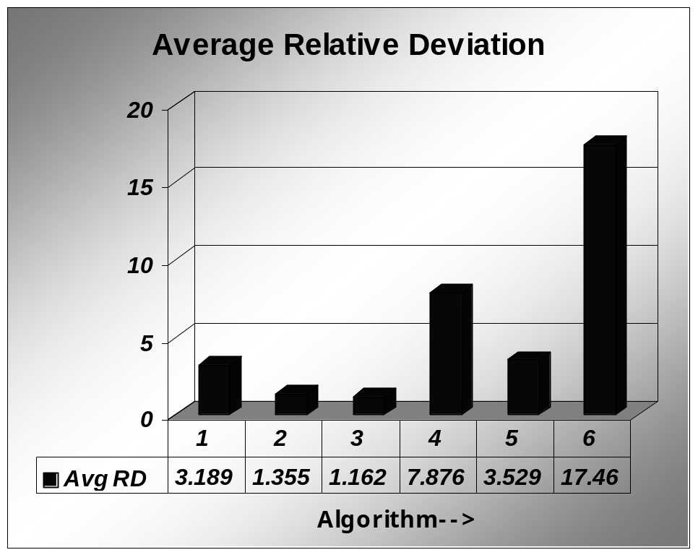
Fig 8.4 ARPD comparison chart

Maximum Relative Percentage Deviation (MRPD)

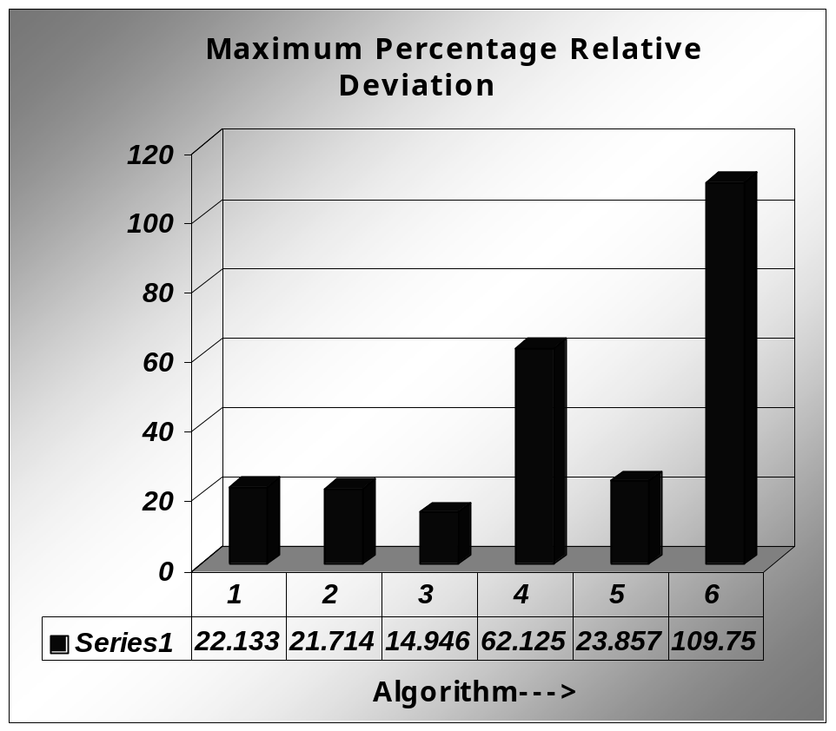

Fig 8.5 MRPD comparison chart

Weighted Average

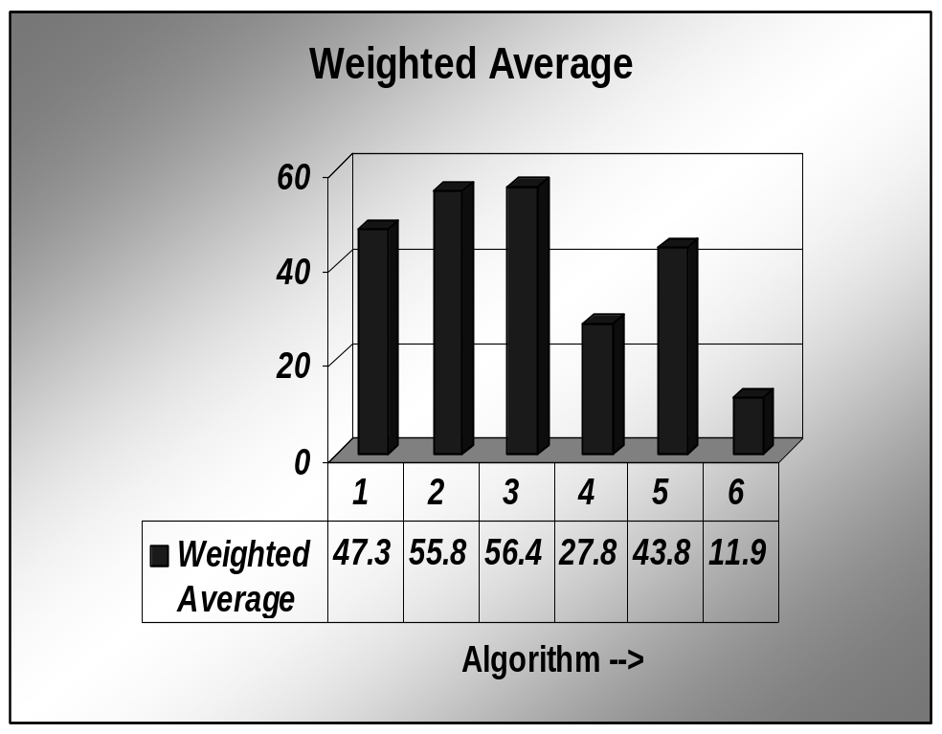

Fig 8.6 Weighted Average comparison chart

Average Ranking

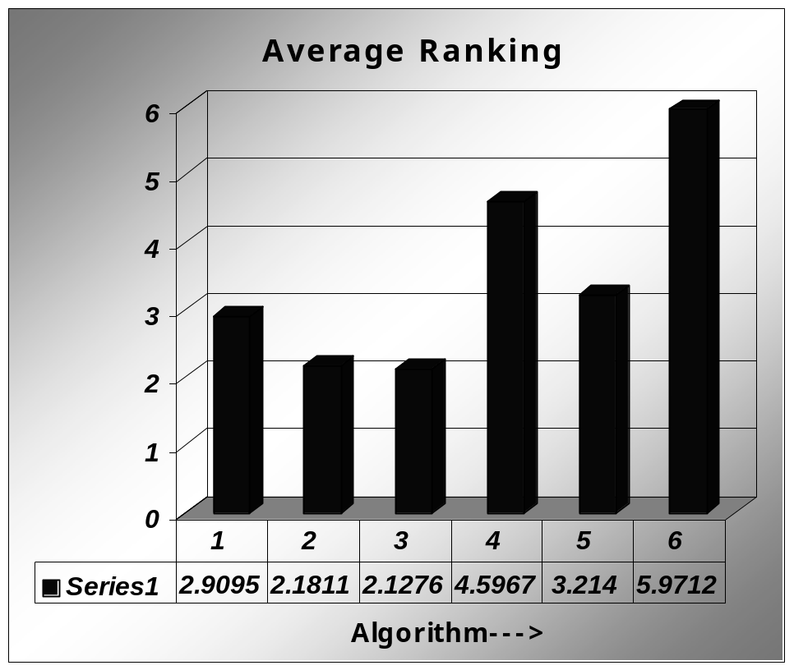
Fig 8.7 Average Ranking comparison chart

Average Penalty

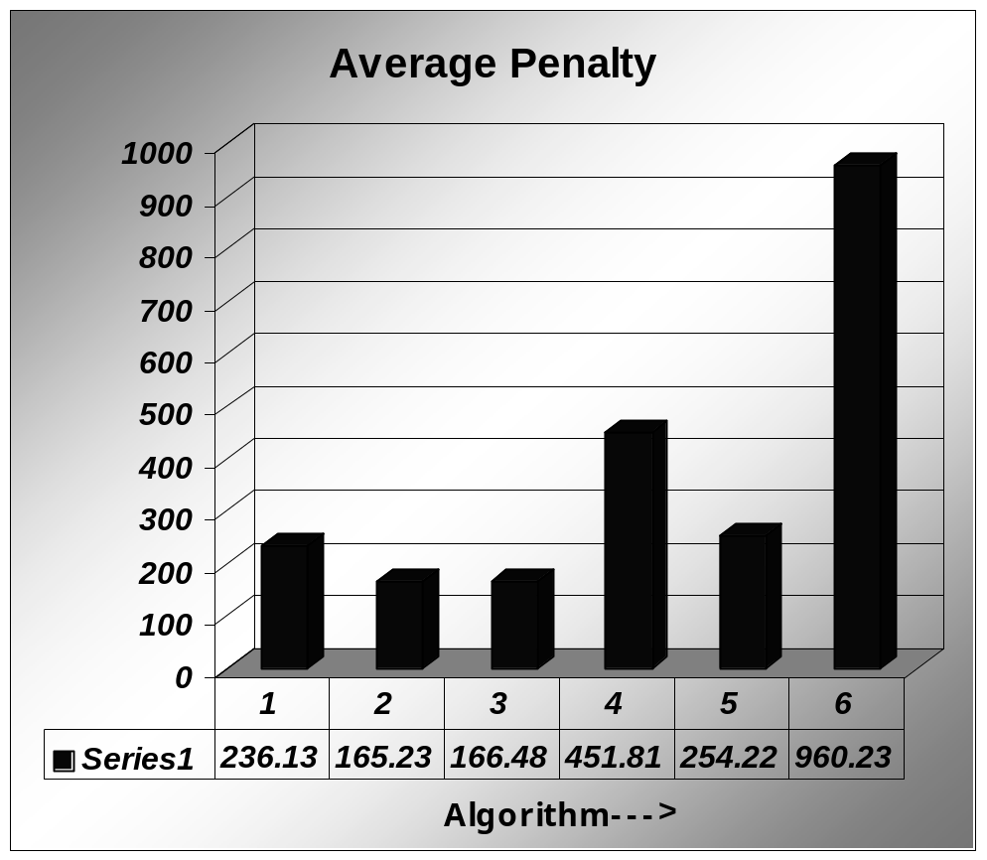

Fig 8.8 Average Penalty comparison chart

9. TESTING, VERIFICATION AND VALIDATION

Testing
As testing plays a major role in assuring the quality of software developed, we tested our Scheduling of Marketing Executive using various standard testing strategies. Even though software cannot be guaranteed 100% error free, testing the software in different phases increases the quality and reliability of the software.

Code Testing
This testing is done to test the logic of the program. This ensures that the code behaves exactly as expected. To do this all statements of our software have been executed giving suitable input data. Values that violate various constraints have been given to test the software.

Program Testing
Each and every function has been tested independent of other functions. This has been done without considering the interaction between functions. Checking of whether suitable error messages are being displayed has been done.

System Testing
The integration of various modules of prototype DSS is tested and the incompatibilities between them have been eliminated. Testing

has been done to check whether formats accepted by all the modules are uniform.

User Factor Testing
The marketing executive scheduling software is tested using layman’s point of view. The user interface must be such that even a person not having sufficient computer knowledge will be able to understand and use the software.

Verification and Validation
Like Testing, Verification and Validation is also important. The main difference between Verification and Validation is,
- Verify: To establish the truth or correctness, or validity by examination.
- Validate: Make valid (execute with the proper formalities); ratify.

Verification
In SME, we try to verify whatever we accept from the user. For example, the “No. of Maximum Visits in a Day”, must be a positive number. If a user has entered an alphabet or some other character other than number, then an error message saying that only numeric characters must be entered is displayed.

Validation
The “Scheduling period” should have the start date, which comes before the end date. It makes no sense for anyone to have “Scheduling period” negative. So here, we validate the “Scheduling Period” by comparing the start date with the end date, and display a suitable message, if it is negative.

10. CONCLUSION
Personnel scheduling problems are becoming increasingly important, as business become more competitive, service oriented and cost conscious in the global environment. One such scheduling problem encountered by a large electronics manufacturing company in India, has been discussed in this project. For this problem a (0-1) goal-programming model and heuristic model have been developed and applied using company data.

Both the models consider customers’ closing days, their expected level of business-interactions with the company, the executive’s (a) weekly holidays, (b) holidays for individual customers, (c) general holidays (if any), and (d) routine head-office full day visits in the planning period, and the company’s requirement of minimum and maximum visits per day.

The main contribution of this project is in problem identification and development of an appropriate model for scheduling the visits of a marketing executive. The main drawback of goal programming approach is that it takes around 4-5 days to provide a solution. Hence heuristic model has been proposed. The various heuristic algorithms have been ranked according to their penalty and various other performance measures and the best algorithm is chosen. A prototype DSS has been designed for this purpose.

11. FUTURE ENHANCEMENTS

This project is concerned with scheduling of a single ME; we can extend the project to include details for scheduling of several marketing executives.

Simulation feature in MMM hasn’t been incorporated in our project. As a future enhancement we propose to include simulation feature also.

We wish to make our project more Dynamic by allowing the user to change the results being displayed and to conclude from it, whether the changes are allowable to the particular instance. Reports can be generated for Customers and ME.

12. BIBLIOGRAPHY

- A (0-1) Goal programming approach for scheduling the tour of a marketing executive, Dr. M. Mathirajan and R. Ramanathan, IISC, Bangalore and Sultan Qaboos University, Oman.

- Personnel scheduling, Bedworth, D.D., Bailey, J.E., Integrated
  - production control systems: Management, Analysis and Design,
  - 2nd Edition, 387–420. Wiley - New York.

- Management models and industrial applications of linear programming Charnes A., Cooper, W.W., 1961. Wiley, New York.

[4] http://help.sap.com

13. USER MANUAL

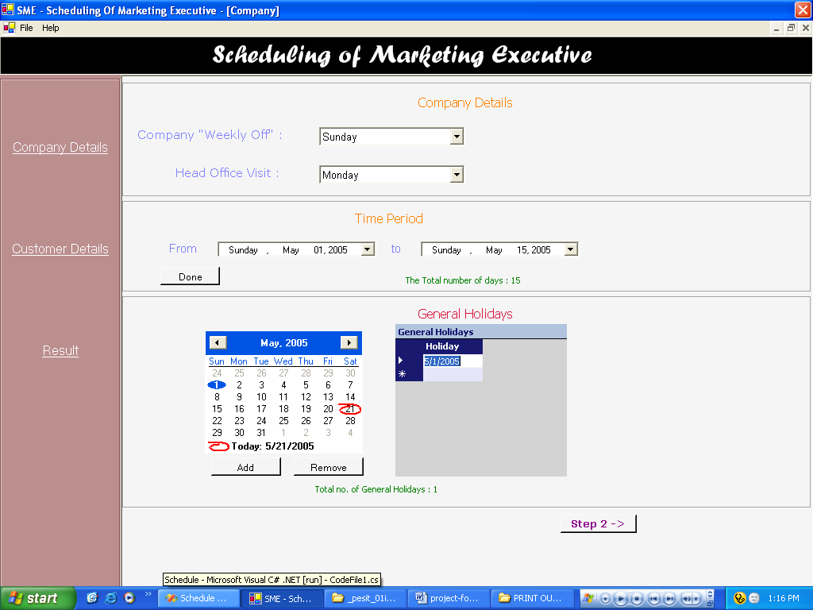

Fig 13.1 Accepting Company Details

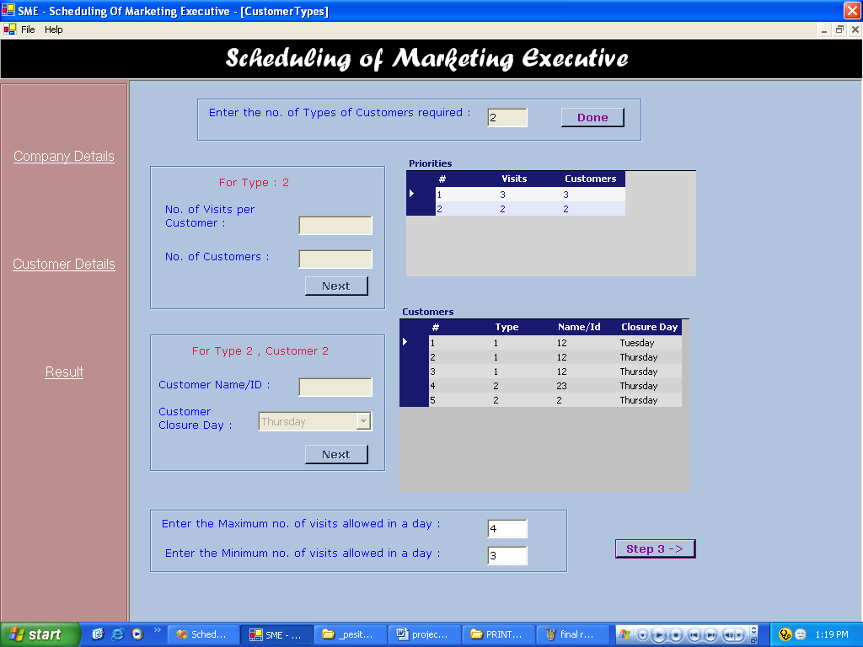

Fig 13.2 Accepting Customer Details

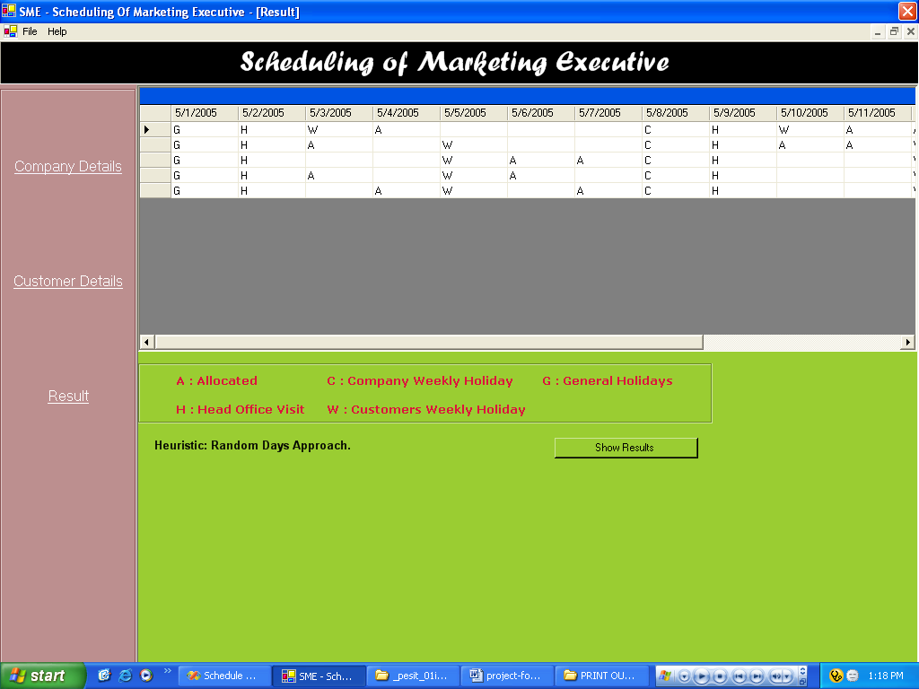

Fig 13.3 Result Display

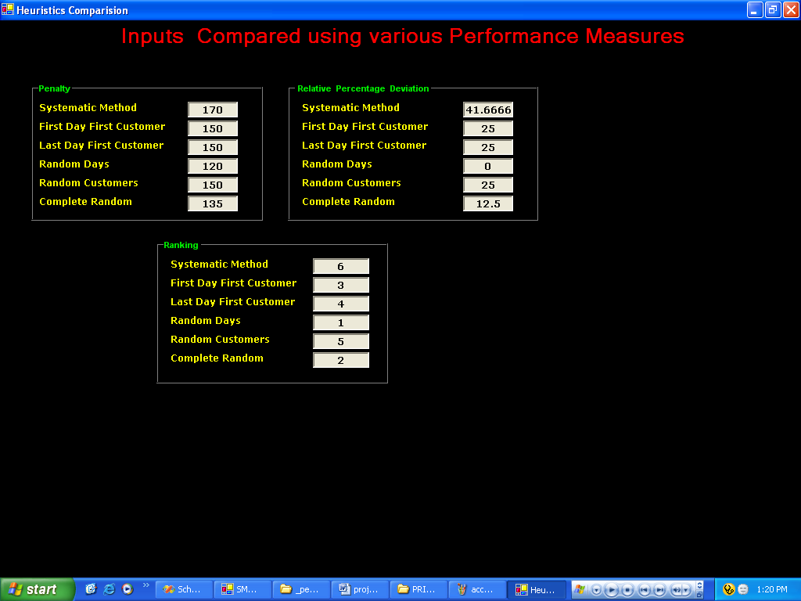

Fig 13.4 Performance Measures for Justifying Algorithm Selection

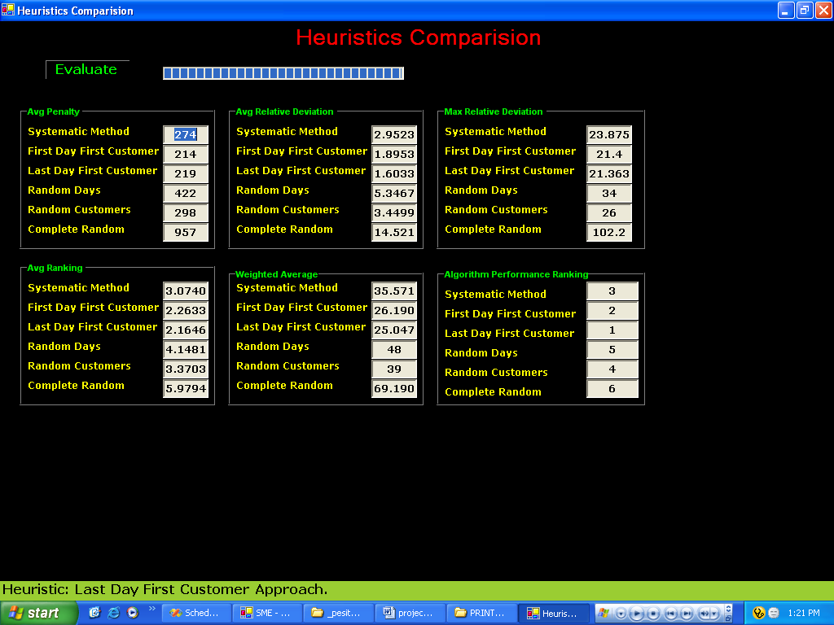

Fig 13.5 Test Data Verification using Performance Measures

